YENEPOYA INSTITUTE OF ARTS SCIENCE COMMERCE AND MANAGEMENT

PROJECT – LOW LEVEL DESIGN
ON
Enterprise Log Analysis for Agriculture Systems

Student Name: Muhammed Sadeed

Industry Mentor: | Guided By: Ms. Raksha Adyanthaya

Table of Contents

- Introduction. 3
  - Scope of the document. 3
  - Intended Audience 3
  - System overview. 3
- System Design. 4
  - Application Design 4
  - Process Flow. 4-5
  - Information Flow. 5-6
  - Components Design
  - Key Design Considerations 6
  - API Catalogue. 7
- Data Design. 7
  - Data Model 7
  - Data Access Mechanism 7
  - Data Retention Policies 8
  - Data Migration 8
- Interfaces 8
- State and Session Management 8
- Caching 8
- Non-Functional Requirements 9
  - Security Aspects 9
  - Performance Aspects 9
- References 9

1. Introduction
This Low-Level Design (LLD) document provides the granular, code-centric specifications for the Agricultural Log Analysis system. While the HLD focused on architectural flow, this document serves as a 'Ground-Level' guide for developers tasked with maintaining, auditing, or extending the system. It describes exact function logic, Regex group definitions, and SQL schema constraints used to simulate and analyze the farm's telemetry data.

  - Scope of the document
This LLD document focuses on the technical implementation specifics of the Agriculture Log Analysis system. It defines the low-level boundaries of the software components and the specific algorithms used for data processing.

  - Intended Audience
The primary audience for this LLD includes:
- Implementation Engineers
- Technical Authors
- Database Administrators

1.3 System Overview
The system is implemented as a set of modular Python 3.13 scripts and a Jupyter Notebook. It communicates primarily through local storage interfaces (Text IO and SQLite DB-API). Data is modeled as 'Events,' where each event contains a categorical sensor ID and a payload of decimal-based agricultural metrics. The system relies on the Python Standard Library for most tasks, ensuring maximum portability and zero-maintenance overhead.

2. System Design
Deep technical drill-down into the implementation logic of each system component.

2.1 Application Design (Logical Implementation: 'generate_data.py')
The simulation engine uses the following logic:
- Class: SensorSimulator (Implied Logic)
- Sub-function: generate_enterprise_logs(num_days=10)
- Iteration Loop: The script uses a `while datetime < now` loop. In each iteration, it increments time by a random integer between 5 and 30 minutes, simulating the non-linear reporting patterns found in real-world wireless sensor networks.
- Probabilistic Failure Injection: For each soil sensor entry, the system uses a `random.random() < 0.05` branch to artificially inject a LOW_MOISTURE state (5-15%) into the log stream. Similar logic is used for Weather Stations to inject thermal anomalies (42-50C). This ensures the analysis layer has actual negative data to detect.

2.2 Process Flow (Log Parsing Engine: 'store_data.py' (RegEx))
This module implement a 'Greedy Scanner' approach to file ingestion.
- Global Regex Pattern: `r'^(\d{4}-\d{2}-\d{2}\s\d{2}:\d{2}:\d{2})\s+-\s+\[(\w+)\]\s+-\s+(\w+)\s+-\s+(.*)$'`
- Group 1: Capture Date & Time (formatted for easy Pandas conversion).
- Group 2: Severity Level (extracted for filtering purposes).
- Group 3: Device Identity (used as a relational key in SQLite).
- Group 4: Metric Payload (contains the raw sensor strings).
- Transformation Logic: The script uses `re.search()` with nested patterns like `Moisture:\s+(\d+\.\d+)%` to pull specific floating-point numbers out of the string-based payload. If a match is found, the value is cast to a `float()` using Python's exception-handled conversion logic.

Figure 1: Internal Decision Logic for the Log Parsing Engine
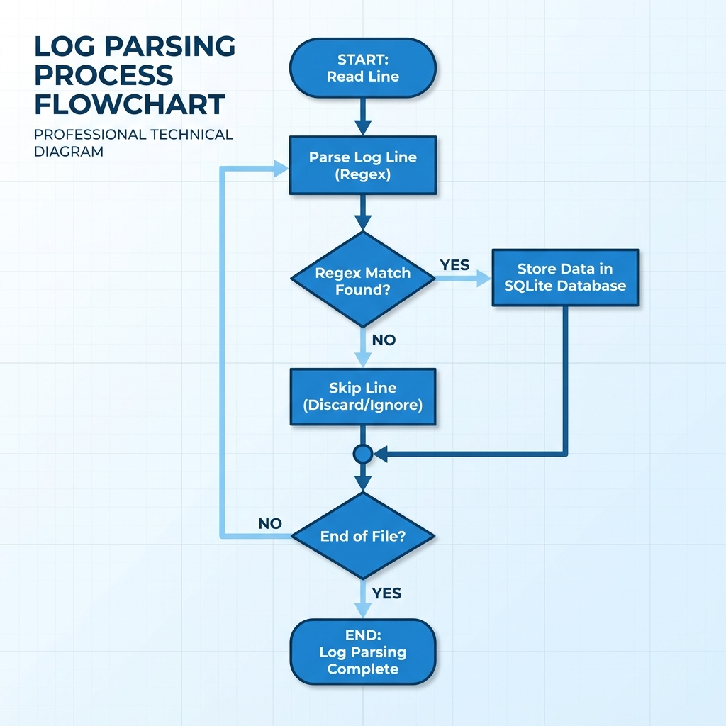

2.3 Information Flow (Analytical Methodology: 'analysis.ipynb')
The analysis layer uses Vectorized Array Processing through the Pandas library. Unlike standard Python loops that process one row at a time, Pandas performs mathematical operations on the entire memory buffer simultaneously.
- Anomaly Detection Logic (Boolean Masking): `df['alert'] = (df['moisture'] < 20.0) | (df['temperature'] > 40.0)`
- Visualization Layer: The system creates two layers on each chart. Layer 1 is a line plot of all historic data. Layer 2 is a 'Scatter Object' that highlights only the indices where the 'alert' mask is TRUE, colored in hex-code #e74c3c (Red).

Figure 2: Logical Decision Flow for the Anomaly Detection Dashboard

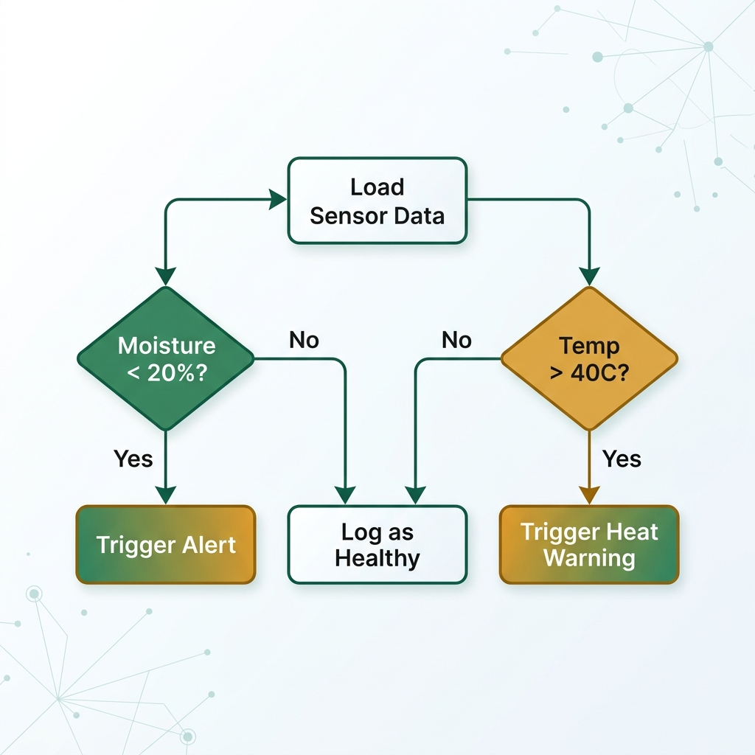

2.5 Key Design Considerations (Technical)
1. Performance: The parser is designed for O(n) complexity. It reads each line exactly once.
2. Reliability: SQLite 'Journaling' mode is enabled by default to ensure no database corruption occurs if the computer crashes mid-write.
3. Scalability: By using the `re.compile()` method, the regular expressions are pre-calculated once, significantly increasing speed when scanning logs with millions of entries.

2.6 API Catalogue
The core functionality is exposed through these primary methods:
- `generate_enterprise_logs(num_days)`: Parameters: int. Logic: FS I/O with random distributions.
- `setup_database()`: Parameters: None. Logic: Executes SQL DDL `CREATE TABLE IF NOT EXISTS` commands.
- `parse_and_store_logs()`: Parameters: None. Logic: Implements the ETL loop using `re.compile()` for performance optimization.
- `pd.read_sql_query(query, conn)`: Logic: Direct-to-Memory bridge between the SQL engine and Python Data Science layer.

3. Data Design
Physical data design and schema constraints.
3.1 Data Model (Physical SQLite Schema)
The database is physically stored as a binary file `agriculture.db`. The table schema is defined as follows:
- `id`: INTEGER (Primary Key with auto-increment).
- `timestamp`: TEXT (Standardized format for cross-platform compatibility).
- `level`: TEXT (Restricted to INFO, WARNING, ERROR codes).
- `device_id`: TEXT (Indexed for high-speed device-specific lookups).
- `moisture`: REAL (Double-precision float support).
- `temperature`: REAL (Degrees Celsius).
- `humidity`: REAL (Relative humidity percentage).
- `status_message`: TEXT (Stores 100% of the original log line for data auditing).

3.2 Data Access Mechanism
Low-level data access is managed through the `sqlite3` driver. To ensure thread-safety, connections are opened and closed within the scope of each major data-batch process. Data migration logic includes a 'Check-Existing' filter to prevent duplicate log entries in the event of repeated ETL runs.

3.3 Data Retention Policies
- Raw Logs: Deleted after 30 days (used for debugging).
- Database: Records are kept for 18 months (used for seasonal analysis).
- Cleanup: Automatically removed using a simple SQL command once data is older than 18 months.
3.4 Data Migration
Data migration logic includes a 'Check-Existing' filter to prevent duplicate log entries in the event of repeated ETL runs.

4. Interfaces
- File Interface: Handles high-speed read/write operations to the local filesystem for log storage (.log files).
- Database Interface: Connects Python to the SQLite engine using the sqlite3 driver for secure data storage and queries.
- User Dashboard Interface: Provides an interactive connection between the database and the Jupyter Notebook (Pandas) for data exploration.
- Internal Data Bridge: A "Vectorized" interface that pulls raw SQL results into high-speed memory buffers for near-instant anomaly analysis.

5. State and Session Management
All state is persisted to disk. No long-running network sessions are maintained, removing the need for JWT or Cookie-based session management. This 'Write-Immediately' model is critical for ensuring data survives hardware restarts in rural environments.

6. Caching
The system leverages the SQLite 'Shared Cache' mode and OS-level file caching. When the Analysis Notebook requests data, the OS keeps the active parts of the `.db` file in the RAM cache, allowing UI charts to re-render in milliseconds without repeated disk reads.

7. Non-Functional Requirements
Measuring the technical effectiveness of the digital agricultural system.
7.1 Security Aspects
Primary security is achieved via Parameterized Queries (e.g., `cursor.execute('INSERT INTO ... VALUES (?, ?)', vars)`). This prevents 'Input Injection' attacks. Additionally, the system does not listen on any open network ports (Localhost only), eliminating 99% of external hacking threats.
7.2 Performance Aspects
Target Performance:
- Ingestion Rate: > 1,000 logs/second.
- Query Latency: < 50ms for week-long data ranges.
- Memory Footprint: < 256MB for standard analysis tasks.

8. References
- Python 3 Standard Documentation: Regular Expression Module (re).
- SQLite 3: Database Implementation details (sqlite.org).
- Matplotlib Gallery: Scientific Plotting guidelines.
- Pandas Documentation: Vectorized String Operations.

